# BASEX+ Software Requirements

# BASEX+ is an TXAir charger that allows you to select whether TXAir broadcasts and control LED behavior based on charging current.

*This document is intended to describe details of BASEX+* software requirements.

## State Diagrams of The System

### 1.1 BaseX+ working Diagram

## 

## Design Details

### 2.1Led display change rule

|  |  |  |  |  |
| --- | --- | --- | --- | --- |
| Communicable card | Percentage of voltage |  |  |  |
| ADC data | >=95% | 0-95% | 0 | Unreadable voltage |
| >=283 | Charging, orange | Charging, orange | Overcharge, orange | Jump to no communication card logic |
| 30<=adc<=283 | Full, green | Abnormal, red | Abnormal, red | Insert backward, not insert |

|  |  |
| --- | --- |
| Non-Communicable card |  |
| Adc data |  |
| >=283 | Charging, orange |
| 30<=adc<=283 | Full, green |
| 0<=adc<=30 | Insert backward, not insert |

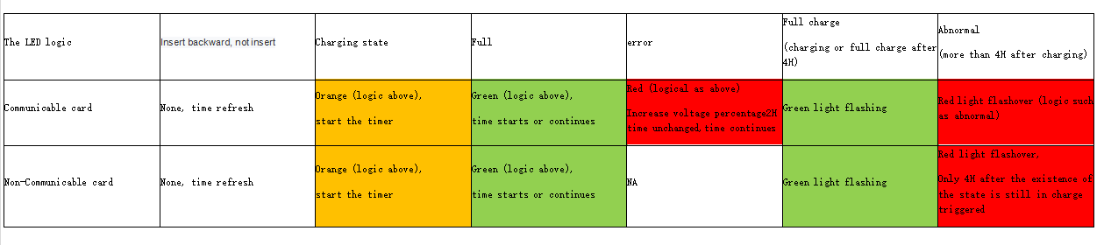

## 2.2 Usart communication Format

### 2.2.1 Usart communication Format

**[Baud](D:/Youdao/Dict/8.9.3.0/resultui/html/index.html" \l "/javascript:;)** **[rate](D:/Youdao/Dict/8.9.3.0/resultui/html/index.html" \l "/javascript:;): 9600 [Data](D:/Youdao/Dict/8.9.3.0/resultui/html/index.html" \l "/javascript:;)** **[bits](D:/Youdao/Dict/8.9.3.0/resultui/html/index.html" \l "/javascript:;): 8 [Parity](D:/Youdao/Dict/8.9.3.0/resultui/html/index.html" \l "/javascript:;)** **[check](D:/Youdao/Dict/8.9.3.0/resultui/html/index.html" \l "/javascript:;)** **[bit](D:/Youdao/Dict/8.9.3.0/resultui/html/index.html" \l "/javascript:;): no Stop bit:1**

|  |  |  |  |  |
| --- | --- | --- | --- | --- |
| The frame header | len | order | data | Check sum |
| 0xFF 0x55 | 1 bytes | 1bytes | N bytes | 1 bytes |

### 2.2.2 Usart communication Instruction sheet

|  |  |
| --- | --- |
| Order | Function |
| 0x00 | BaseX+ query TXAir current power level |
| 0x01 | BaseX+ notifies TXAir to start charging the time stamp |
| 0x02 | BaseX+ notifies TXAir of the end of charging time stamp |
| 0x05 | Inform TXAir to turn on or off the broadcast |

### 2.2.3 Functional specifications

Query power level:

Note: Device returns current voltage level (%)

Send: BaseX+ -> TXAir

|  |  |  |  |  |
| --- | --- | --- | --- | --- |
| The frame header | len | order | data | Check sum |
| 0xFF 0x55 | 0x00 | 0x00 | no | xx |

Return: TXAIR-> BaseX+

|  |  |  |  |  |
| --- | --- | --- | --- | --- |
| The frame header | len | order | data | Check sum |
| 0xFF 0x55 | 0x01 | 0x00 | Percentage of electric quantity | xx |

Example: Query current power, TXAir current power is 100%

- Send ： FF 55 00 00 AA

- Return： FF 55 01 00 64 XX

Notify TXAir to start charging:

Send: BaseX+ -> TXAir

|  |  |  |  |  |
| --- | --- | --- | --- | --- |
| The frame header | len | order | data | Check sum |
| 0xFF 0x55 | 0x04 | 0x01 | The UTC time stamp | xx |

Return: TXAIR-> BaseX+

|  |  |  |  |  |
| --- | --- | --- | --- | --- |
| The frame header | len | order | data | Check sum |
| 0xFF 0x55 | 0x00 | 0x01 | no | xx |

Example: Start charging for Tue Aug 27 16:22:47 CST 2019

(UTC Time stamp 1566894167 = 0x5D64E857)

- Send ： FF 55 04 01 5D 64 E8 57 xx

- Return： FF 55 00 01 XX

Notify TXAir to end charging:

Send: BaseX+ -> TXAir

|  |  |  |  |  |
| --- | --- | --- | --- | --- |
| The frame header | len | order | data | Check sum |
| 0xFF 0x55 | 0x04 | 0x02 | The UTC time stamp | xx |

Return: TXAIR-> BaseX

|  |  |  |  |  |
| --- | --- | --- | --- | --- |
| The frame header | len | order | data | Check sum |
| 0xFF 0x55 | 0x00 | 0x02 | no | xx |

Example: End charging time: Tue Aug 27 16:22:47 CST 2019

(UTC Time stamp 1566894167 = 0x5D64E857)

- Send ： FF 55 04 02 5D 64 E8 57 xx

- Return： FF 55 00 02 XX

Inform TXAir to turn on or off the broadcast:

Send: BaseX+ -> TXAir

|  |  |  |  |  |
| --- | --- | --- | --- | --- |
| The frame header | len | order | data | Check sum |
| 0xFF 0x55 | 0x01 | 0x05 | Broadcast on/off identifies 1 byte | xx |

Return: TXAIR-> BaseX+

|  |  |  |  |  |
| --- | --- | --- | --- | --- |
| The frame header | len | order | data | Check sum |
| 0xFF 0x55 | 0x00 | 0x05 | no | xx |

- Turn on  Broadcasting ： FF 55 01 05 01 xx

- Turn off  Broadcasting：FF 55 01 05 00 xx

- Return：FF 55 00 05 XX

## 2.3 Firmware Download

1. Connect the fixture to PC with a ST-LINK
2. Download firmware by the STVP tool.

## 2.4 How to play:

1. Insert the TXAir card into the BASEX+ card slot correctly

# BASEX+ Hardware Information